Multiple-choice section – choose the correct answer

Question 1 [3.1]

Expanding  gives:

A  B  C  D 

Question 2 [3.1]

Expanding and simplifying  gives:

A  B  C  D 

Question 3 [3.1]

 is equivalent to:

A  B  C  D 

Question 4 [3.1]

Expanding and simplifying  gives:

A  B  C  D 

Question 5 [3.2]

Factorising  gives:

A  B  C  D 

Question 6 [3.4]

Expanding  gives which dilation factor for the graph of  from y = x2?

A 4 B  C 2 D 8

Question 7 [3.4]

Which statement concerning the transformation from  = (x – 2)2 to  = -(2x – 4)2 – 3 is false?

A The dilation factor of  is 4. B  translated 2 units right produces.

C There is a reflection about the x-axis. D  moves vertically 3 units down.

Question 8 [3.5]

When factorised, x2 – 11x + 24 is:

A (x – 3)(x – 8) B (x – 3)(x + 8) C (x – 6)(x – 4) D (x + 3)(x + 8)

Question 9 [3.6]

When factorised, x2 + 6x + 9 is:

A (x – 3)2 B (x + 3)(x – 3) C (x + 3)(x + 2) D (x + 3)2

Question 10 [3.7]

 simplifies to:

A  B  C  D 

Multiple-choice results: ___ / 10

Short answer section

Question 11 2 marks [3.5]

Use words from the list below to complete the following sentences.

algebraic fractions quadratic trinomial binomial product perfect squares

difference of two squares factorising highest common factor monic

(a) ______________ involves taking out the highest common factor of terms.

(b) x2 – x – 36 is an example of a __________________ quadratic.

Question 12 2 marks [3.6]

Explain the term perfect squares. Use the expansion of  and the factorisation of to help you explain.

___________________________________________________________________________

___________________________________________________________________________

___________________________________________________________________________

Question 13 3 marks [3.1]

Expand .

Question 14 3 marks [3.2]

Factorise .

Question 15 3 marks [3.4]

Explain the transformations required to obtain  from y = x2.

Question 16 4 marks [3.4]

Sketch the graph of using transformations applied to y = x2.

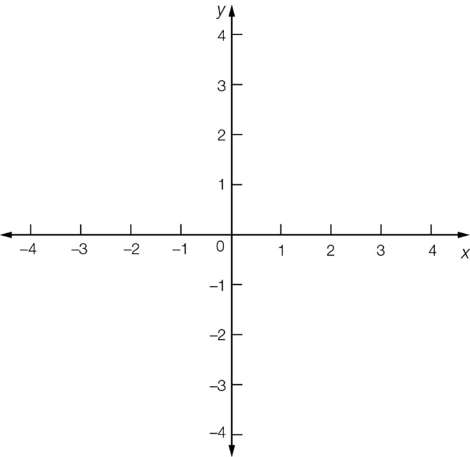

Question 17 3 marks [3.5]

(a) Substitute x = a + 2 into (a + 2)2 + 4(a + 2) – 5.

(b) Factorise your answer to part (a).

(c) Substitute x = a + 2 into your answer to part (b) and simplify.

Question 18 3 marks [3.6]

Use the factorisation of  to factorise .

Question 19 3 marks [3.6]

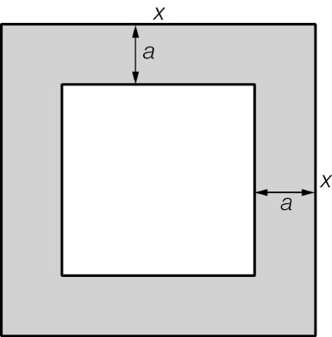

(a) Write expressions for the areas of the large square and the small square.

(b) Write the expression for the shaded area and factorise the result.

Question 20 3 marks [3.2, 3.6]

Factorise .

Question 21 3 marks [3.7]

Simplify.

Question 22 4 marks [3.7]

Write with a common denominator and simplify the expression.

Short answer results: ___ / 36

Extended answer section

Question 23 4 marks [3.6]

(a) Given that , factorise .

(b) Use your answer to part (a) to factorise .

Question 24 4 marks [3.5]

The height h m of a ball above the ground at time t seconds after it is thrown from a roof is given by h = -t2 + 3t + 28.

(a) How high is the ball above the ground when it is first thrown?

(b) When is the ball at ground level?

Question 25 6 marks [3.1, 3.2]

The diagram shows part of the floor plan of a house consisting of a kitchen A and a lounge room B.

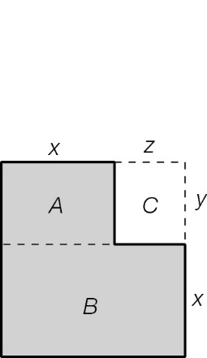

(a) Find an expression for the total area A + B.

(b) Find an expression for the total area that involves subtracting area C.

(c) Show using algebra that your answers to (a) and (b) are equal.

Extended answer results: ___ / 14

TOTAL test results: ___ / 60